QUESTICA BUSINESS PROCESS GUIDE

DATE CREATED | PROCESS NAME
September 3, 2019 | Questica Header Bar and Layout Functions
PROCEDURE NO. | PROCESS OWNER
002 | Questica Campus Users
DATE OF LAST UPDATE | LAST UPDATED BY
September 23, 2019 | Patrick Orona

Table of Contents
QUESTICA BUSINESS PROCESS GUIDE 1
I. INTRODUCTION 2
II. PROCESS 2
Changing Columns and Views 2
Changing Grouping Function 4
Reorganizing Columns 4
Saving Screen Views 6
Fit Columns to Screen / Allow Column Scrolling 7
Freeze / Unfreeze Columns 8
Sort Columns 8
Filter Bar 9
Truncated to 3,000 records 9
III. CHANGE HISTORY 10

INTRODUCTION
PURPOSE | To acquaint users with basic interfaces and tools when working in Questica Budgeting software.
SCOPE | Scope of this document pertains to Humboldt State University’s version of Questica Budgeting software. Topics include right click functionality on the header bar (column bar), saving screen views, and truncated grids.
DOCUMENT MANAGEMENT | University Budget Office (UBO) retains all copies of Business Process Guides (BPG) and handles distribution.

PROCESS
OVERVIEW | Basic interfaces  Screenshots provided for this business process guide (BPG) are from the Operating Module in the Fund-Department and Budgets screen view. However, right click functionality is consistent across all Questica Modules.
STEP | ACTIVITY
To view all Fund – Departments for your respective MBU(s), click the Operating menu in the left hand column.  Then select Fund - Department from the Operating module menu. | 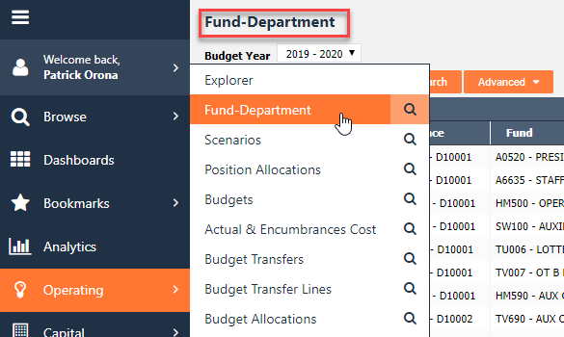

Changing Columns and Views
Fund-Department Default Screen View | 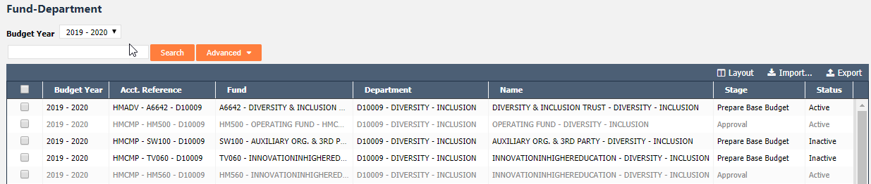
By right clicking on the top header bar, the menu populates.  Choose Selected Columns to change column views. | 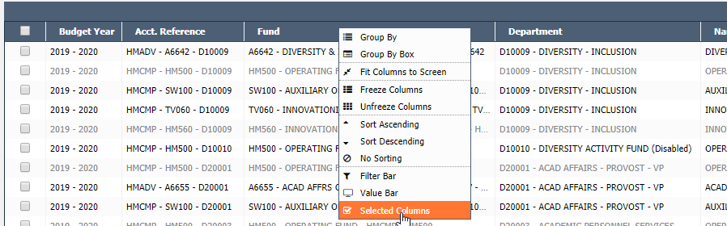
Prompt box titled Grid Options opens, allowing the user to add, remove and reorder columns.  Starred items are those required by Questica when creating an entry. | 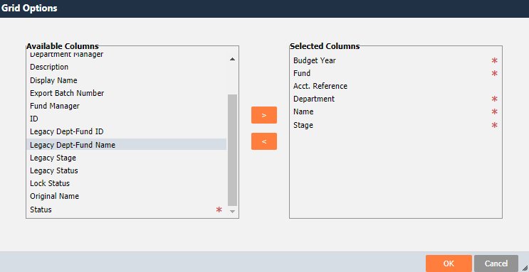
Using Grid Options create user display preference. | 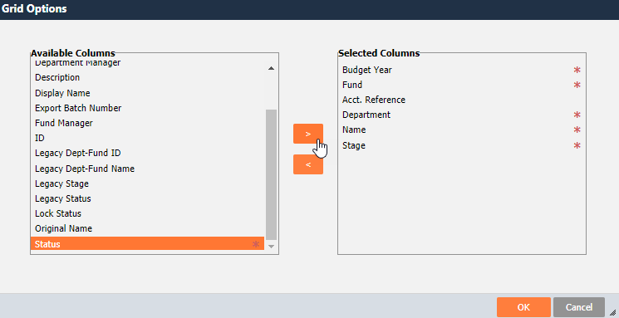
Select OK and changes to view are applied. | 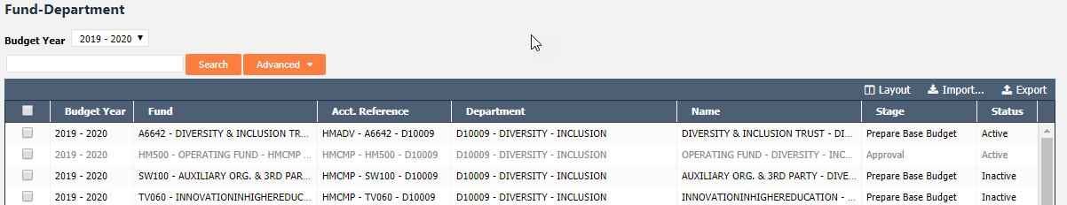

Changing Grouping Function
If wanting to group by any column on the screen, right click on the blue header bar on the selected column. Choose Group By to group items together. | 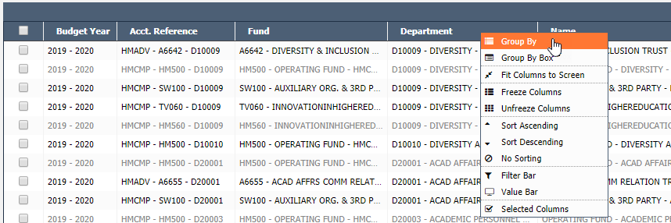
Now you can see the fund-departments grouped by Departments. | 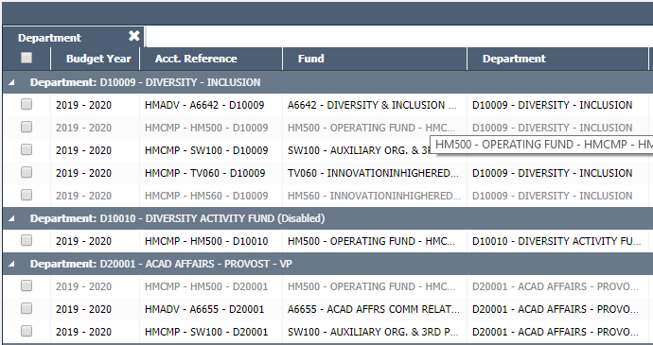
This Group By function works for all columns.  Another example of group by Fund is provided to the right. | 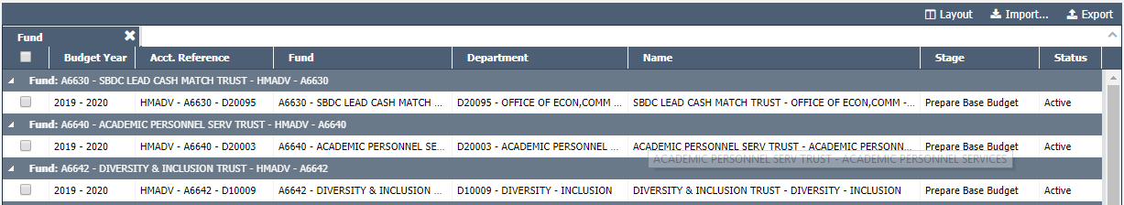

Reorganizing Columns
Users can also reorder the columns to a view that fits their preference.  This can be done two ways; by dragging and dropping or using the grid layout function. | 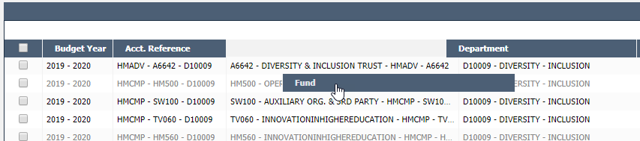
Click and hold the column tile that you would like to move, drag to the area you’d like the column to go. Example to the right shows Department and Fund columns reordered. | 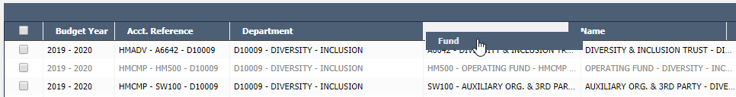
Users can also reorder the column view in the Selected Columns dialogue box when right clicking.
The Grid Options dialogue box shows available columns for view in this module and columns currently viewing. | 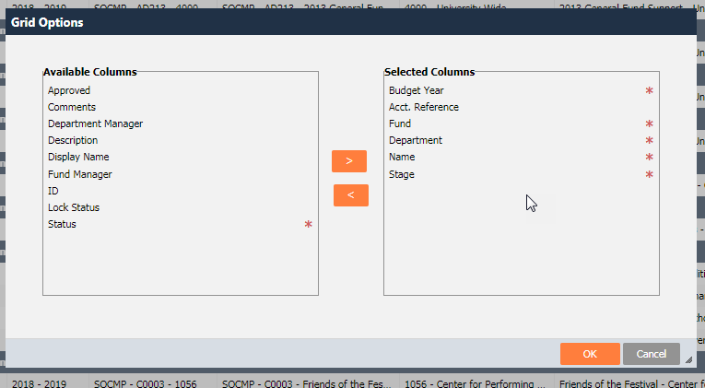
To move the column order in this dialogue box, select the Column Header that you want to move, and drag column to the order that is preferred. | 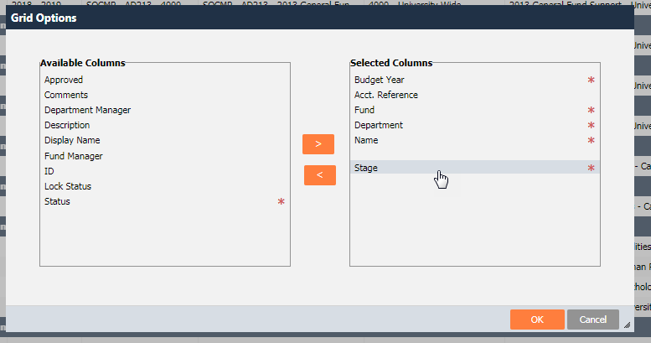
This move will automatically move the rest of the columns within the current view to accommodate the view.  Select OK highlighted in red when ready to see the new view. | 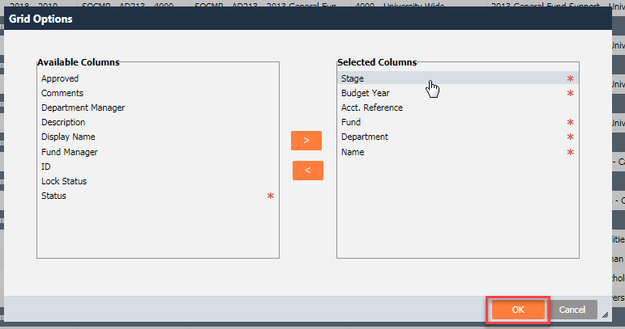
This has now updated your view to the column order as displayed in the previous screen. | 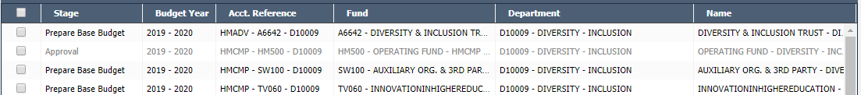

Saving Screen Views
Once a view is set up the user can save the current view in Questica as a Layout.  To save a layout, click on Layout highlighted in orange. | 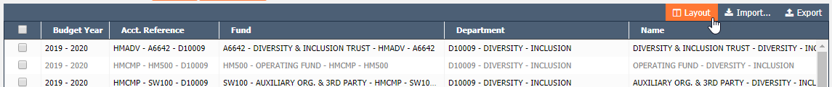
In the drop down menu for Layout, select Save As to save view. | 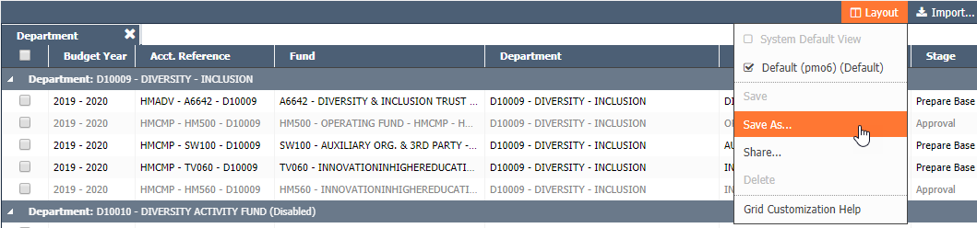
Name the saved layout view and select Save. | 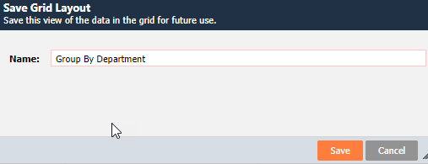
This layout is now saved in this module screen and can be accessed in the future. | 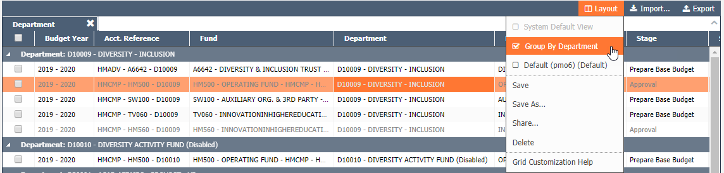

Fit Columns to Screen / Allow Column Scrolling
To view all selected columns on the screen right click on the header bar and select Fit Columns to Screen | 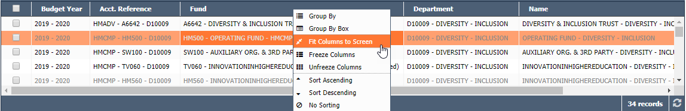
All columns will resize to fit onto screen and scroll bar at the bottom of the screen will be removed. | 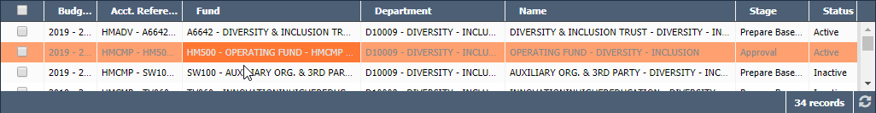
To enable scrolling right click the header bar and select Allow Column Scrolling. | 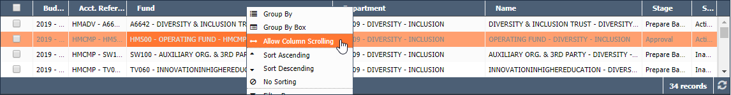
To resize columns place your cursor in-between columns and click and drag for desired width. A scrolling bar will appear for any columns extended beyond the screen. | 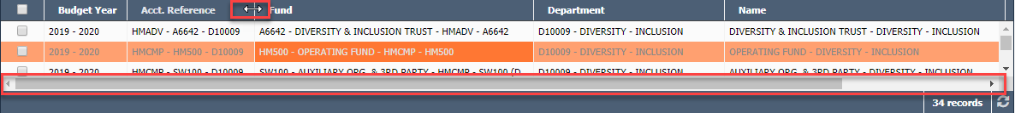

Freeze / Unfreeze Columns
To freeze columns while scrolling right click on desired column on the header bar and select Freeze Columns. Frozen columns will turn dark blue.
To unfreeze right click on hearer bar and select Unfreeze Columns. | 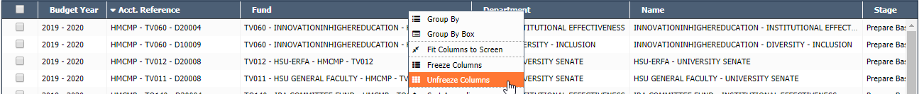

Sort Columns
To sort ascending (A to Z) click once on desired column. | 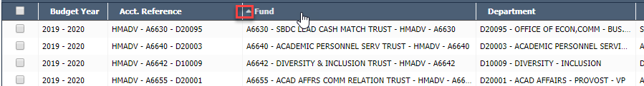
To sort descending (Z to A) click twice on desired column. | 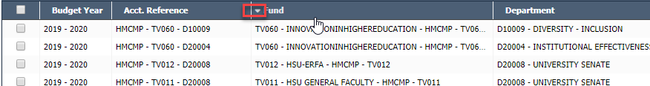
To remove all sorting click three times or until arrow to the left has disappeared

Filter Bar
To filter by columns right click on the header bar and select Filter Bar. | 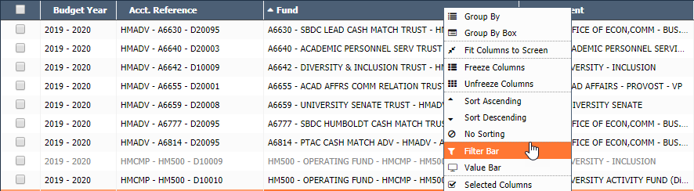
A bar below the header will appear. Start typing values in desired column(s) to filter rows | 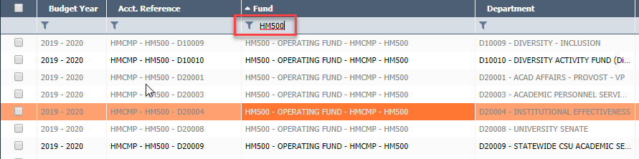
Users may filter on multiple columns

Truncated to 3,000 records
All grids are limited or Truncated to 3,000 records.  Look to the bottom right of the screen to see if the grid is truncated. | 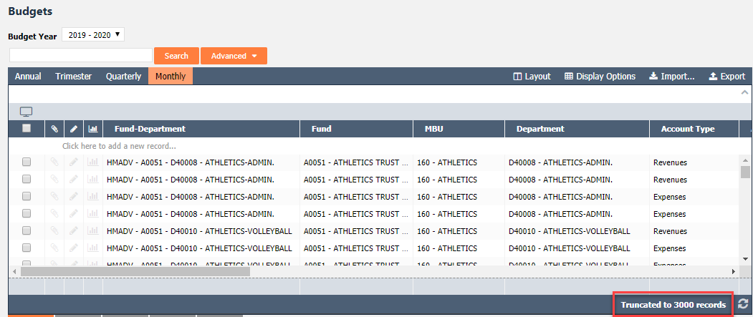
If the grid is truncated filters and simple searches will only return records within the first 3,000.  To search all records within a module use the Advanced Search option. See Budget Lines Grid BPG #003 for detail on how to set up advanced searches. | 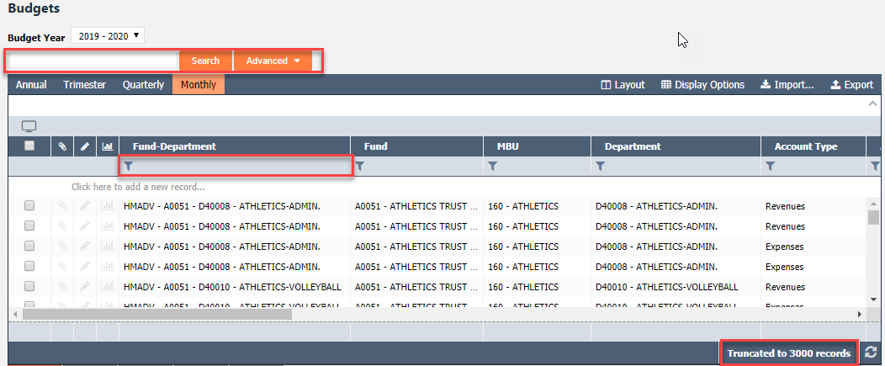  Note: All records, even if the grid is truncated, will be included in an excel export.

CHANGE HISTORY
Section | DATE | DESCRIPTION OF CHANGE IMPLEMENTED | COMPLETED BY
Truncated to 3,000 records | 9/23/2019 | Added truncated to 3,000 records section | 9/23/2019

