QUESTICA BUSINESS PROCESS GUIDE

DATE CREATED | PROCESS NAME
September 3, 2019 | Budget Lines Grid
PROCEDURE NO. | PROCESS OWNER
003 | Questica Campus Users
DATE OF LAST UPDATE | LAST UPDATED BY
September 23, 2019 | Patrick Orona

Table of Contents
QUESTICA BUSINESS PROCESS GUIDE 1
I. INTRODUCTION 2
II. PROCESS 2
Module location and Layout 2
Display Options 4
Advanced Search 5
Save and Share an Advanced Search 9
Right Click within the Grid 11
III. CHANGE HISTORY 11

INTRODUCTION
PURPOSE | View current budgets in the Budgets screen view in the Operating Module.
SCOPE | Scope of this document pertains to Humboldt State University’s version of Questica Budgeting software. Topics include module location & layout, display options, advanced searches and right click options within the grid.
DOCUMENT MANAGEMENT | University Budget Office (UBO) retains all copies of Business Process Guides (BPG) and handles distribution.

PROCESS
OVERVIEW | Budgets screen view.  Screenshots provided for this business process guide (BPG) are from the Operating Module in the Budgets screen view. However, much of what is covered is consistent across most Questica Modules.
STEP | ACTIVITY

Module location and Layout
To view all budget lines for your respective MBU(s), click the Operating menu in the left hand column.  Then select Budgets from the Operating module menu. | 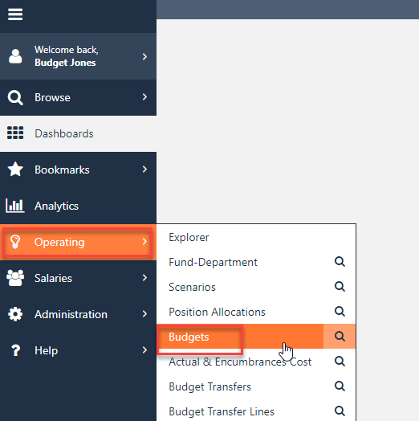
The Budgets screen view does not show data by default.  Select the Search button at the top of the screen. This will produce all budget lines available. | 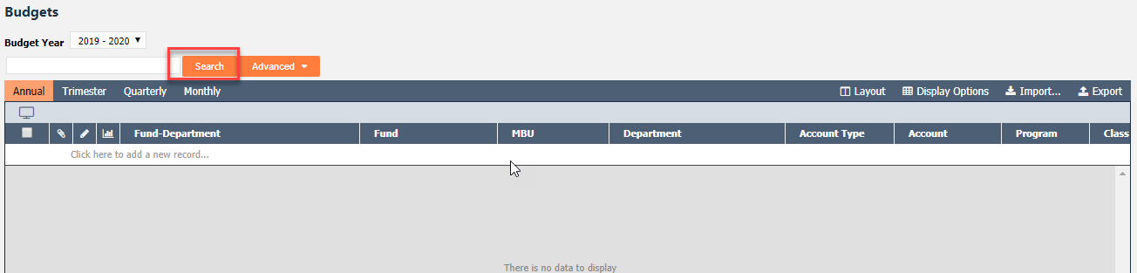
If not already selected, select the Default layout to start with.  Note: See Header Bar and Layout Functions BPG #002 for details on how to create and save a layout. | 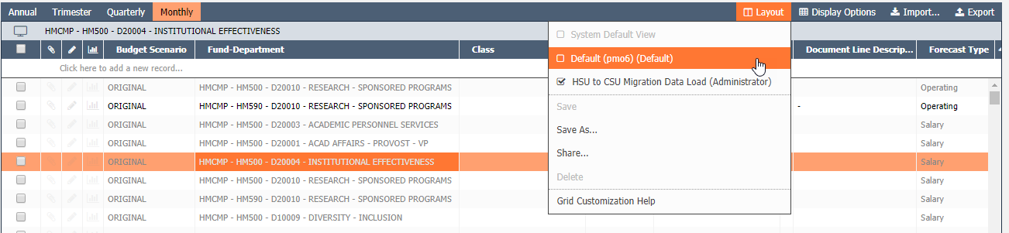
Users can view budgets Monthly, Quarterly, Trimester or Annual by selecting a view in the top left. | 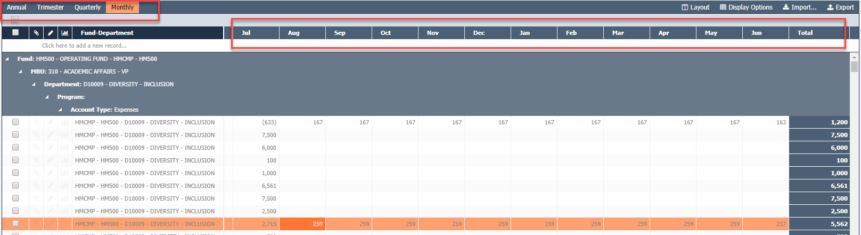
To export the budgets grid to excel select Export to the right of the screen.  In chrome a file will start downloading at the bottom of the browser.  Note: ONLY use the import option for Budget Transfers. | 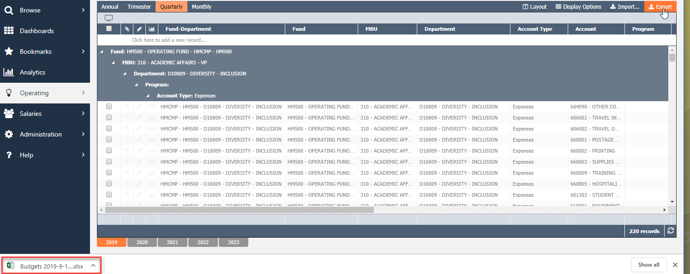
The Budgets grid is limited or Truncated to 3,000 records. Filters and simple searches will only return records within the first 3,000.  To search all records within a grid use the Advanced Search option outlined below.  Note: All records, even if the grid is truncated, will be included in an excel export. | 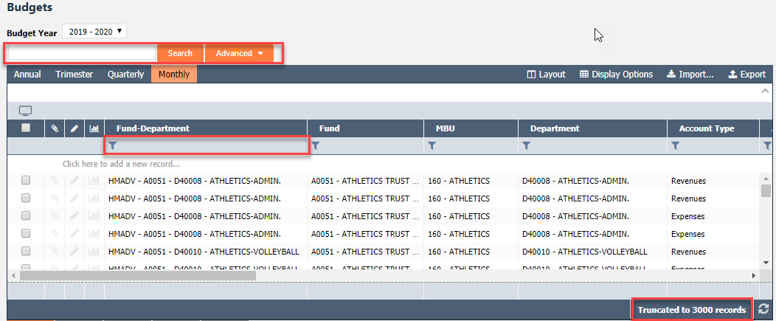

Display Options
A User can also change the grid view by clicking Display Options at the top right and selecting a view from the drop down list. | 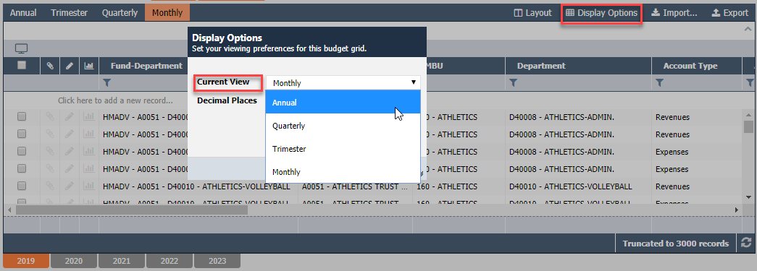
If Annual is selected for Current View users have the option to display one or multiple years within one view tab. | 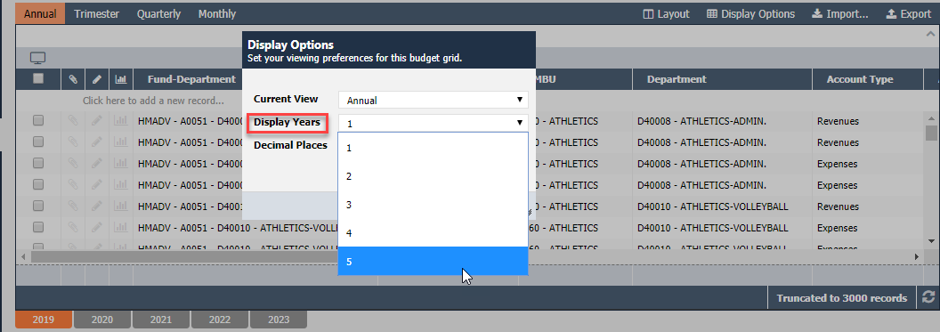
To the right 5 Display Years are now viewable within one tab. | 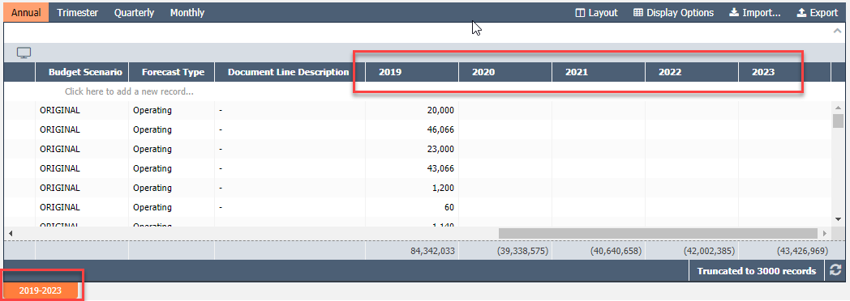

Advanced Search
To create a search based on specific criteria select the Advanced button at the top of the screen. | 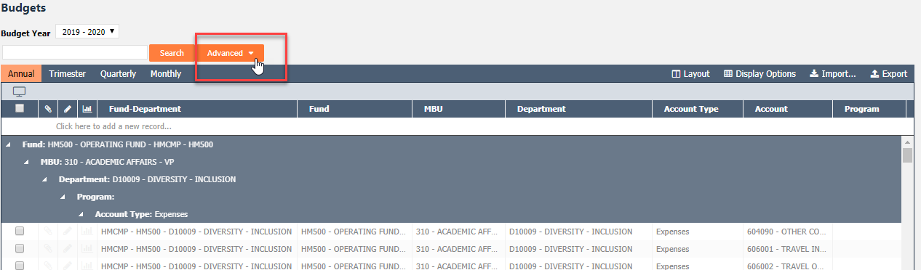
Select Advanced Search from the drop down menu. | 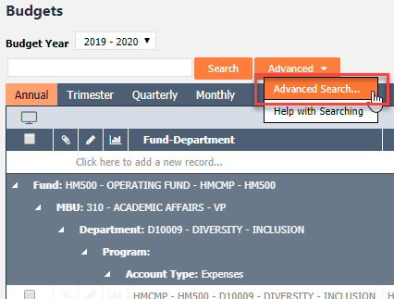
A dialogue box appears for the advanced budget search.  Users can remove, copy & create search criteria as seen to the right. | 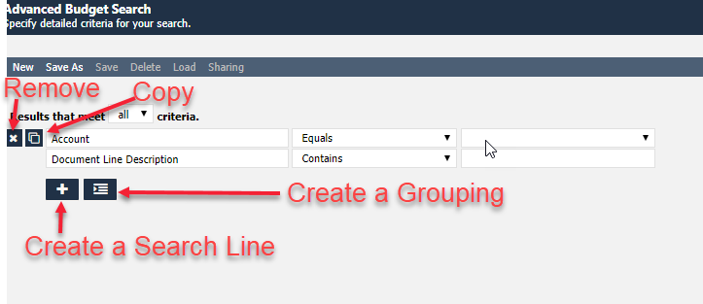
Select the plus button to create, a filter for viewing budgets. | 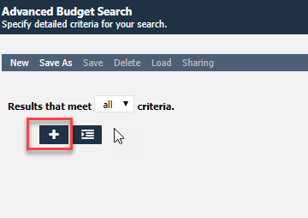
A field picker dialogue box appears, this displays a list of options for filters.  Items that have an arrow in the far right indicate multiple levels of options. | 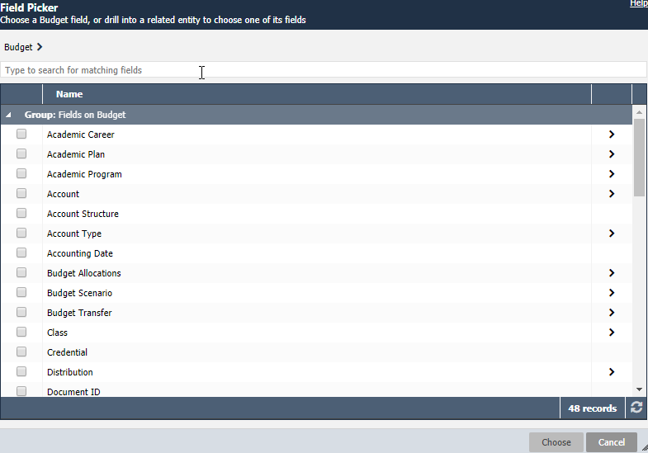
Search by key words at the top.  Select which one of the options is most appropriate.  If the item has an arrow at the end of it, you can select to further drill down, but it is not required.  Select Choose in the bottom right corner. | 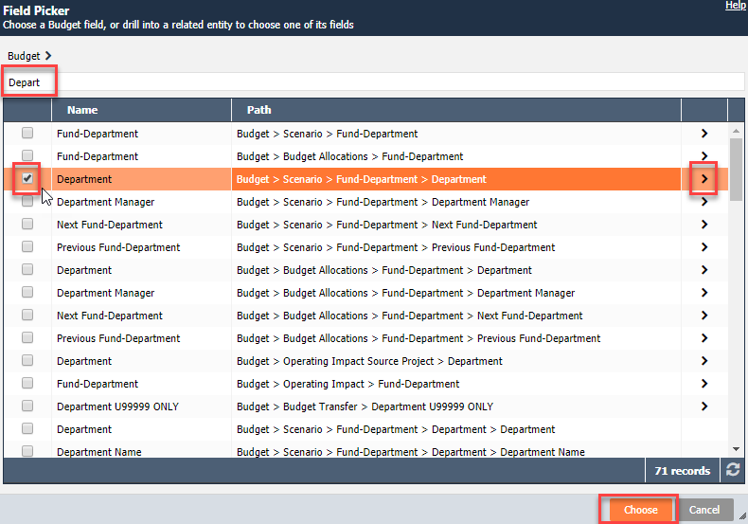
In the event the Choose option at the bottom does not turn orange after checking off the check box, click on another row to enable the Choose option to move forward.  See example to the right showing the row below the checked field clicked on (in orange) and the Choose button at the bottom now an option. | 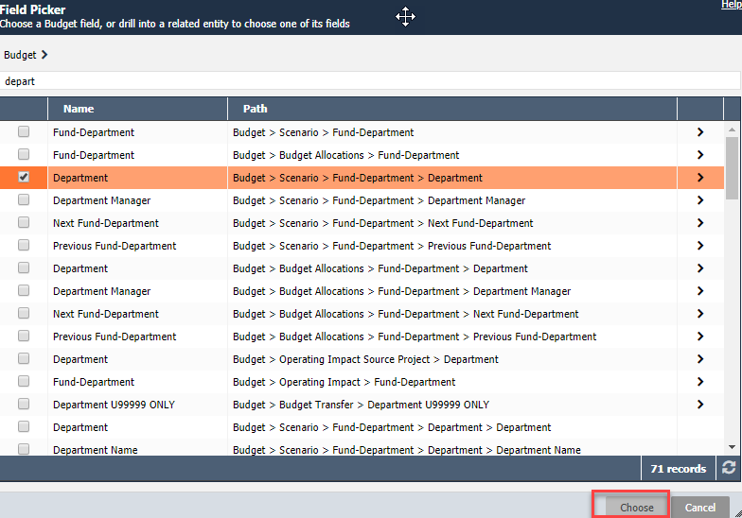  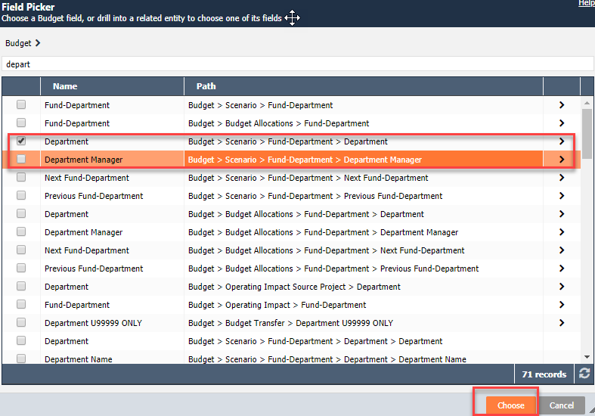
In the first drop down menu select an appropriate operator. | 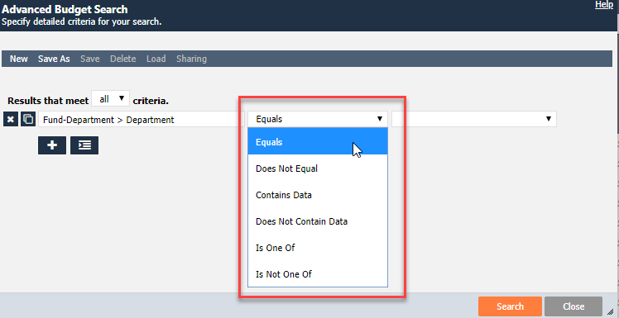
In the next drop down menu select a department.  Note: Budget lines will only be returned for department you have permission to view. | 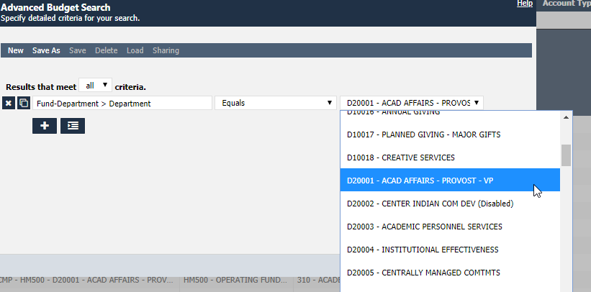
For this example, we are filtering on D20001 – Academic Affairs – Provost – VP.  Once the search criteria is entered, select Search in the bottom right corner. | 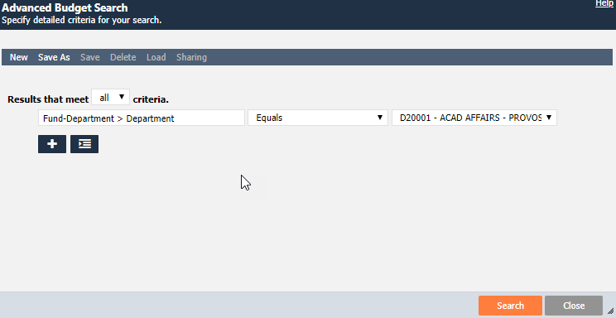
Questica searches through the budget lines using the Advanced filters chosen. | 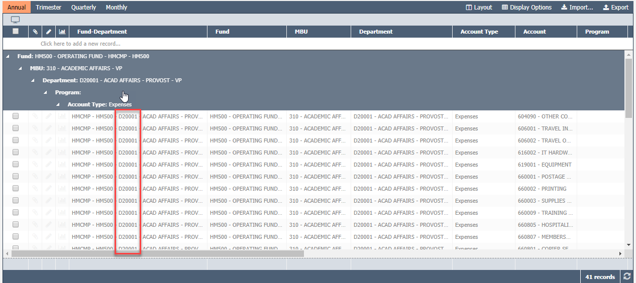
Here is another advanced search example using multiple criteria. | 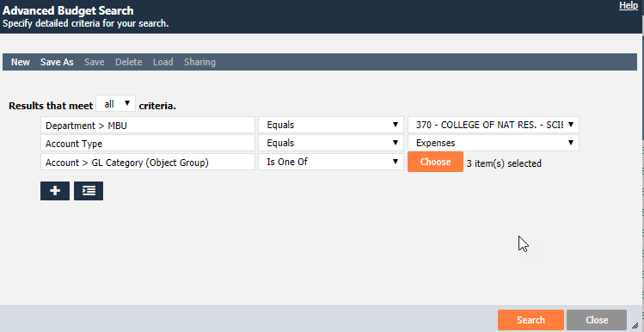

Save and Share an Advanced Search
To save frequently used searches select Save As in the top ribbon. | 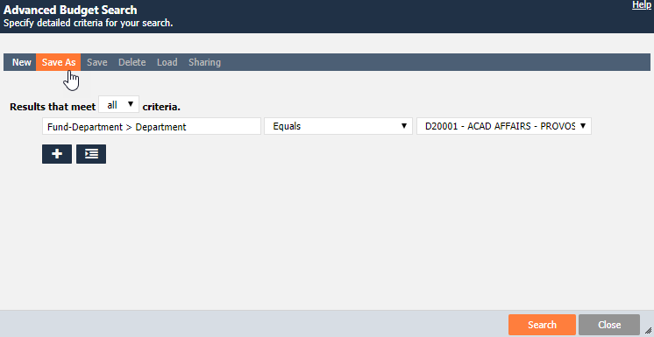
A dialogue box will appear to create a name for the search. Click save when finished | 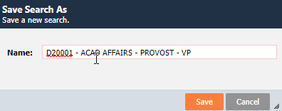
To run the saved search click Load and select from the drop down menu. | 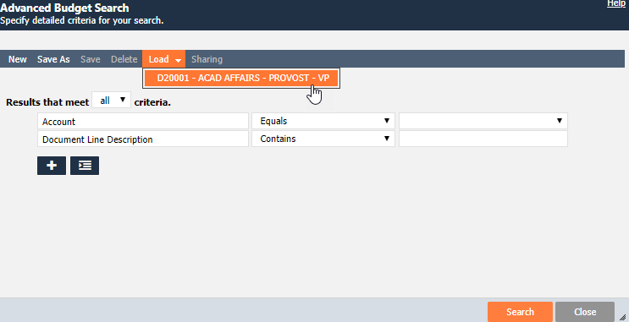
Users can edit and re-Save the search or Delete it using the options seen on the top ribbon.  To run the search click Search on the bottom right. | 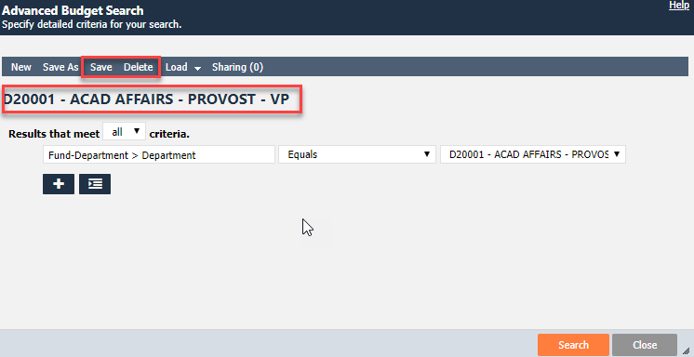
To share the search with other Questica users click Sharing. | 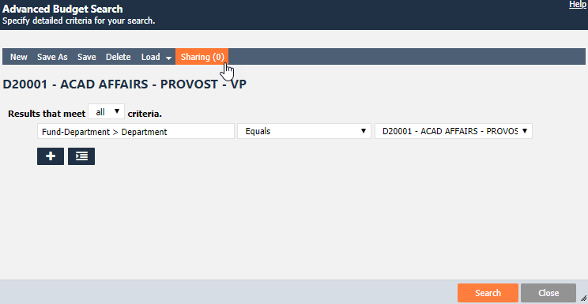
A dialogue box will appear. Select + Add Users  Note: When sharing in Questica share at the User level as Groups are not currently being maintained. | 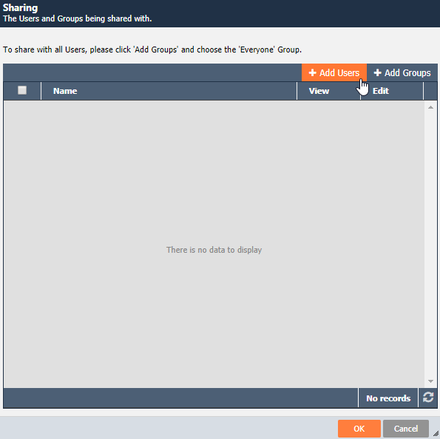
Check users to share the advanced search with and click OK. | 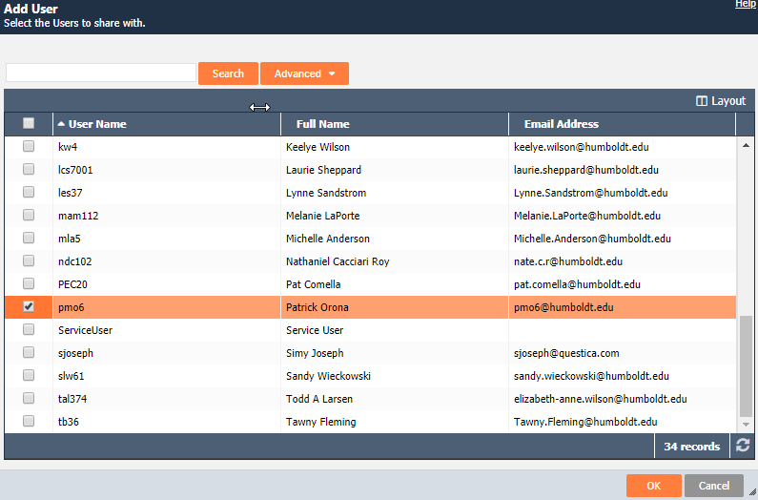

Right Click within the Grid
To open in another tab the Budget Transfer and / or Fund -Department tied to the selected budget line, right click and select. | 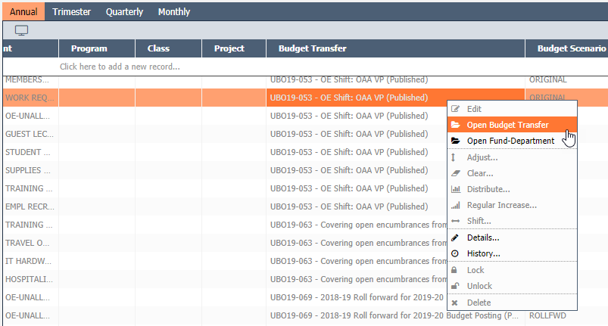

CHANGE HISTORY
Section | DESCRIPTION OF CHANGE IMPLEMENTED | Date | COMPLETED BY
Module location and Layout | Included truncated to 3,000 records detail. | 9/23/2019 | Patrick Orona
Advanced Search | Included field picker work around if Choose option does not work the first time. | 9/23/2019 | Patrick Orona
Display Options | Included display options section | 9/23/2019 | Patrick Orona

