QUESTICA BUSINESS PROCESS GUIDE

DATE CREATED | PROCESS NAME
September 20, 2019 | Analytics Center Module
PROCEDURE NO. | PROCESS OWNER
004 | Questica Campus Users
DATE OF LAST UPDATE | LAST UPDATED BY
September 20, 2019 | Patrick Orona

Table of Contents
QUESTICA BUSINESS PROCESS GUIDE 1
I. INTRODUCTION 2
II. PROCESS 2
Analytics Center Filters 2
Report Parameter Set 3
Report Schedules 4
Ad Hoc Views 6
III. CHANGE HISTORY 12

INTRODUCTION
PURPOSE | Overview of Analytics Center functionality and working with Ad hoc views.
SCOPE | Scope of this document pertains to Humboldt State University’s version of Questica Budgeting software. Topics include Questica Analytics Center functionality and working with Ad hoc views.
DOCUMENT MANAGEMENT | University Budget Office (UBO) retains all copies of Business Process Guides (BPG) and handles distribution.

PROCESS
OVERVIEW | Screenshots provided for this Business Process Guide (BPG) are from the Analytics Center Module and editing within Ad hoc views.
STEP | ACTIVITY

Analytics Center Filters
To view all reports and ad hoc views click on Analytics module in the left panel | 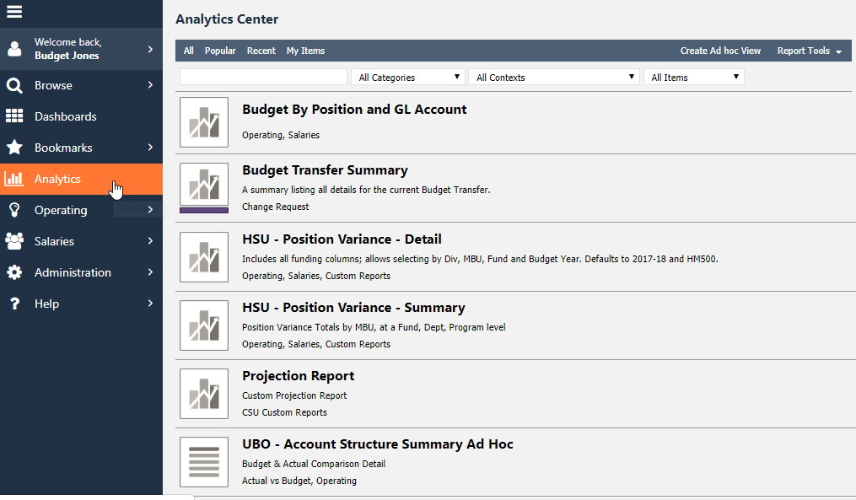
To quickly filter through reports and ad hoc views click through options at the top right. My items return bookmarked and user created reports. | 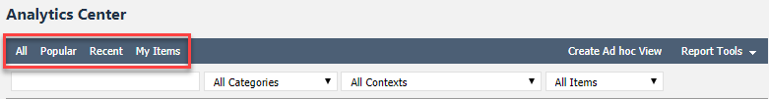
Users can search for a report by typing the name of the report in the search bar.  Users can also filter by All Categories and / or All Contexts from the drop down lists. | 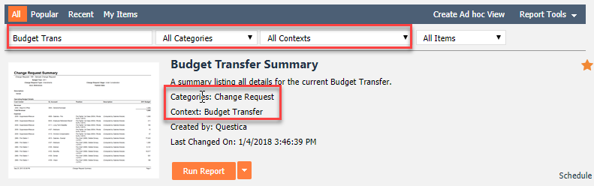
Lastly, Users can filter by Reports or Ad Hoc Views | 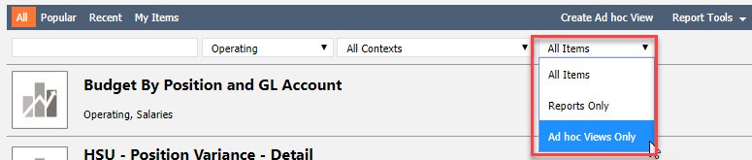
To set up Report Schedules and Report Parameters Sets click on Report Tools at the top right

Report Parameter Set
To save parameters click on Report Parameters Sets seen from the screenshot above.  In the new view click on + New Report Parameters Sets | 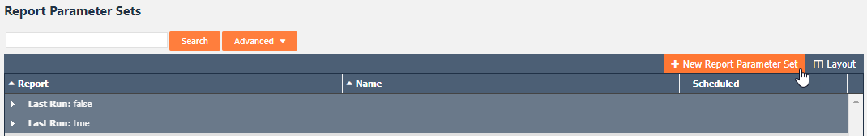
A dialog box will appear. Select a report from the drop-down list and name the parameter set. | 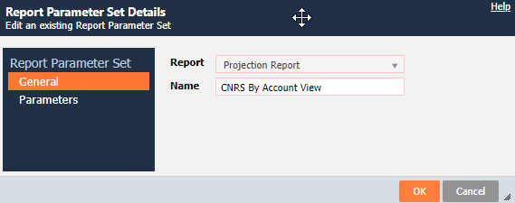
In the Parameters tab go through each of the fields selecting from the drop-down menus and click OK once finished. | 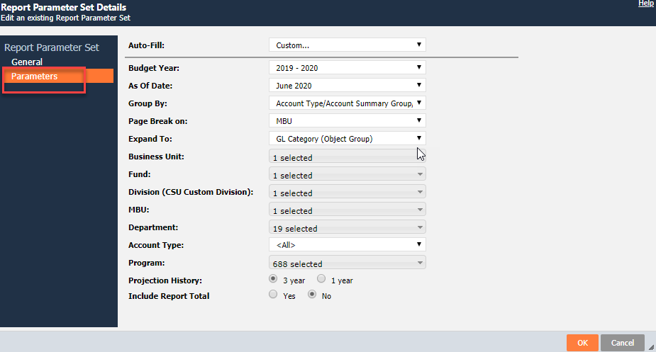
Preset parameters for the report has now been saved. | 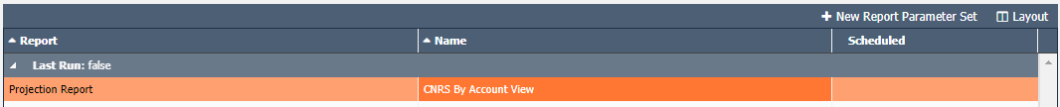

Report Schedules
To schedule reports click on Report Schedules in the Analytics Module under Report Tools.  In the new view click on + New Report Schedule | 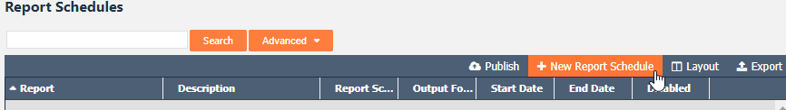
A dialog box will open. Select a report from the drop-down list and fill out all required fields outlined in red.  To send the report to other users check the box by their name. | 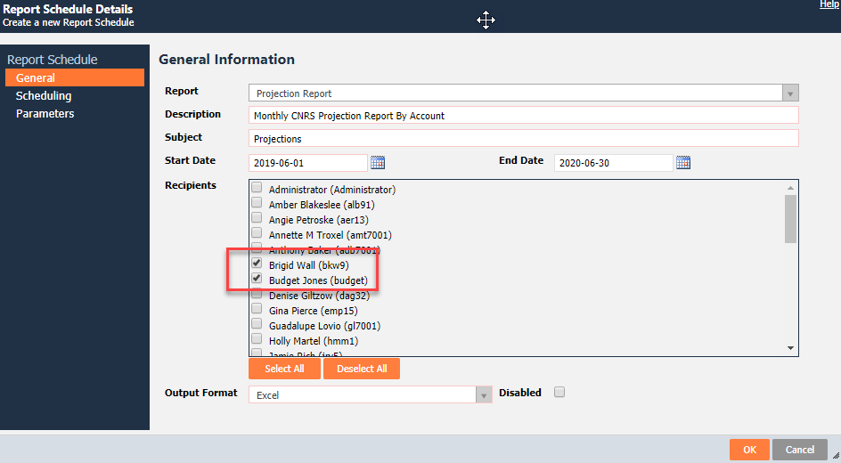
In the Scheduling tab select the frequency in which the report is to be ran and sent as seen to the right. | 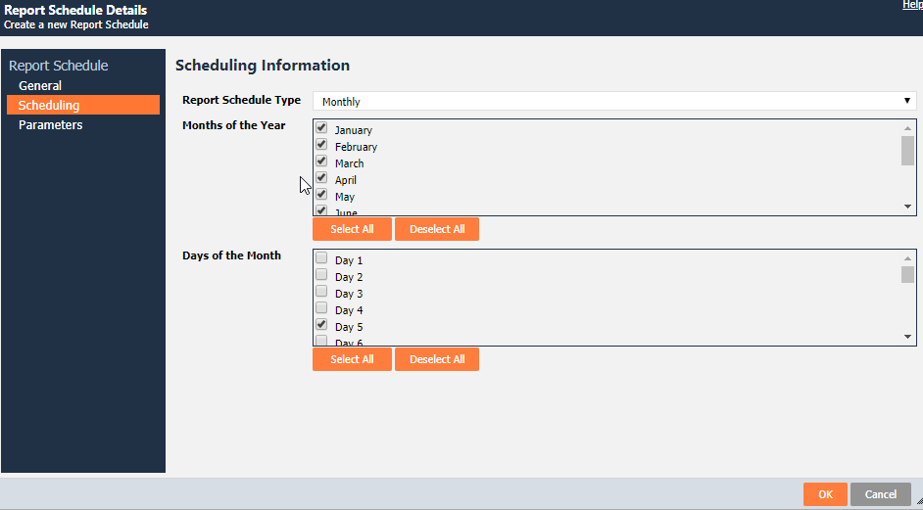
In the Parameters tab select desired parameters from the drop down lists. If saved Report Parameters have already been created, select it from the Auto-Fill drop down list and click OK. | 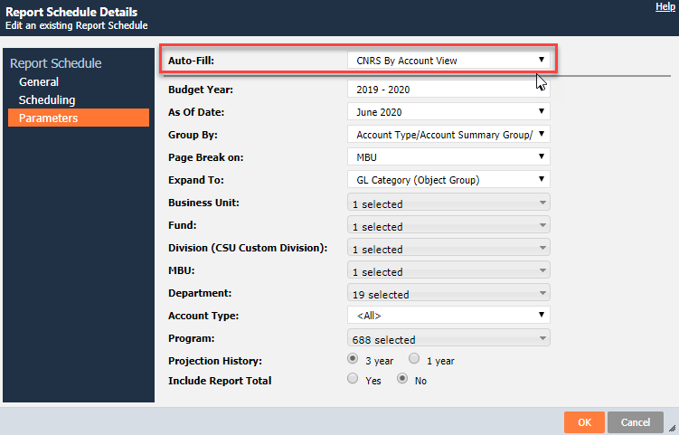
Report Schedule record has now been created. To Edit the name, right click on the record.  To open and Edit, double click on the record. | 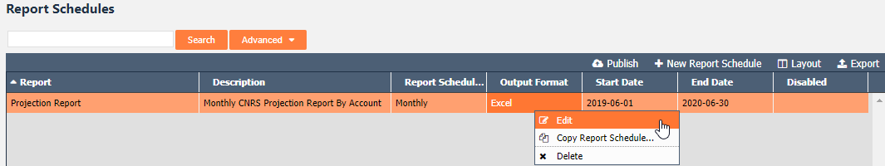
Lastly, select Publish to have reports emailed to you based on the schedule set. | 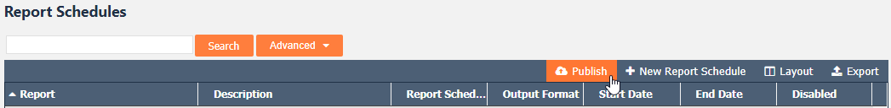
Reports can now be ran using saved Report Parameters and Report Schedules from the report drop down list in the Analytic Center. | 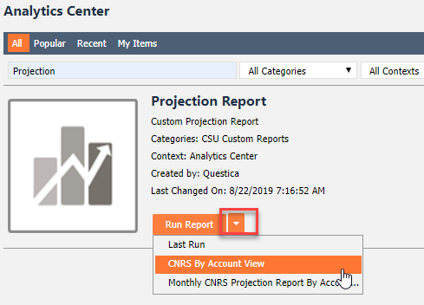

Ad Hoc Views
Ad Hoc Views allow users to choose from available fields (columns) to create a grid to build dashboards, reports and export to excel. | The UBO has created and shared the Account Structure Summary Ad Hoc view which compares Budget to Actuals. In this exercise we will copy over and edit this Ad Hoc View.  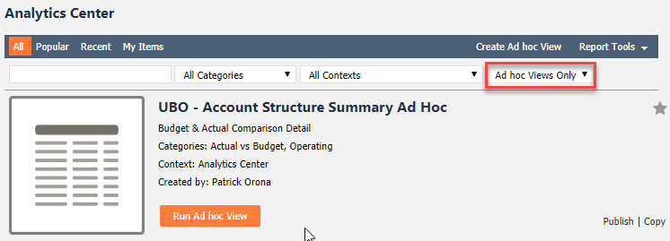
Select Copy to the far right. A dialog box will appear. Rename the Ad Hoc View and click OK | 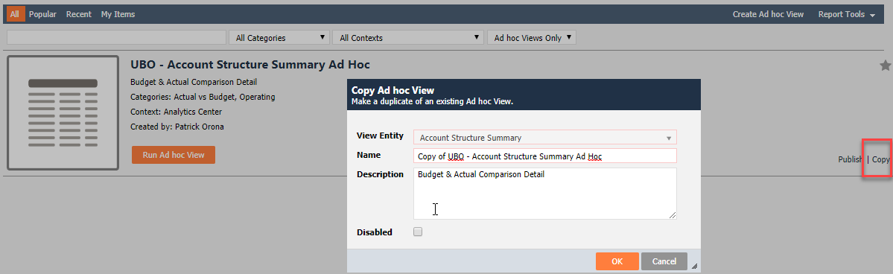
Users can now Edit, Delete, and Publish. Next click Run Ad Hoc View  The Publish option is for report building which will not be covered in this BPG. | 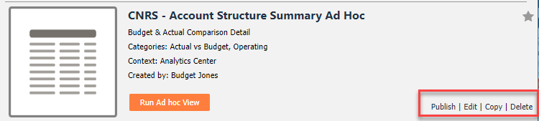
A blank window will appear. Click Search to start returning rows of data. | 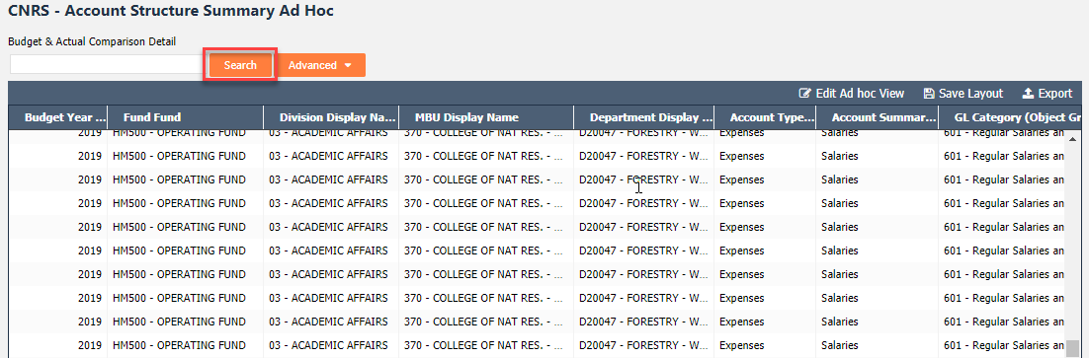
Search, Right Click and Export functionality is the same as the Budgets grid in the Operating Module. See BPG 002 & 003 for details. | 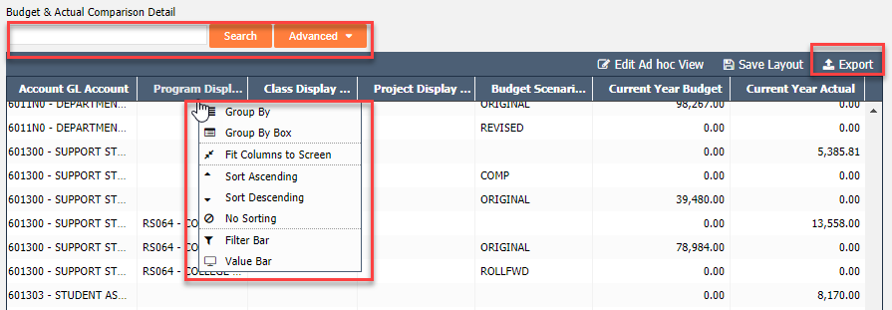
To Edit select Edit Ad Hoc View | 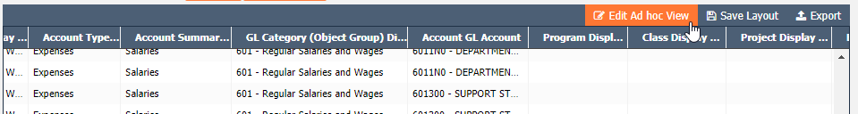
A dialog box will appear. Users can edit Name, Description and Report Categories as appropriate. | 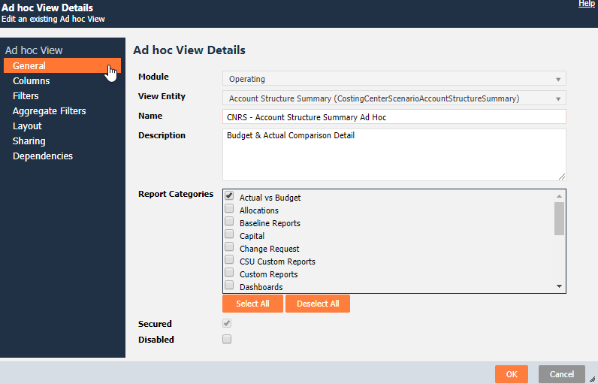
To Remove, Copy or Add a Column see screenshot to the right. | 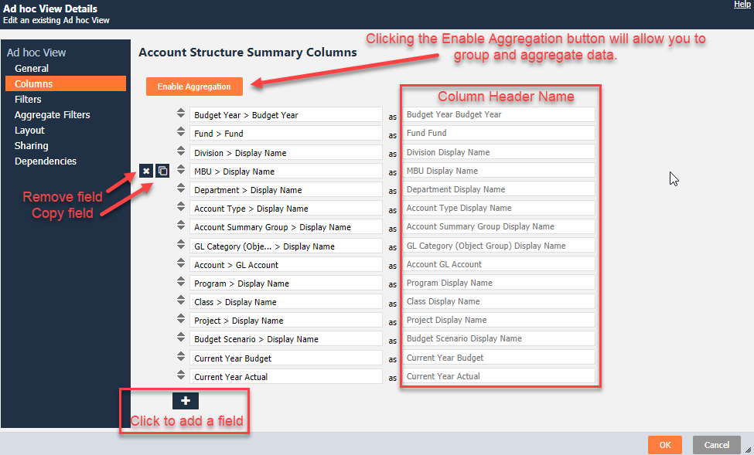
To change aggregation type click the arrow for the drop down list.  To reorder columns click on the double arrows and drag. | 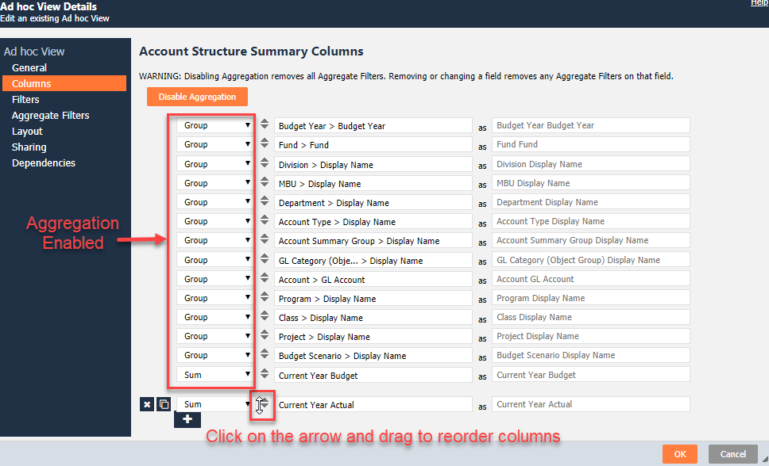
Much like an Advanced Search, after clicking the + button as shown above a Field Picker will appear,  Begin typing in the search bar to return desired fields and click OK. | 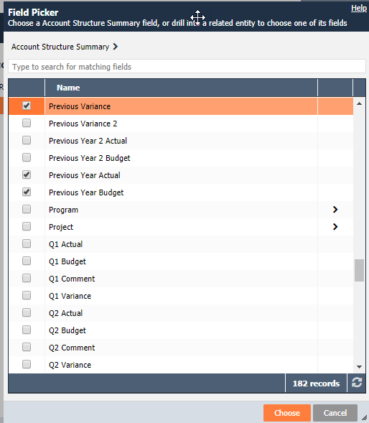
To Filter the Columns selected click the + button to add criteria.  A field picker will appear just as seen above. Filter operates just like Advanced Searches | For this example ad hoc view, we need to ensure that we only show results for “active” budgets – that is, Scenarios that are marked “Active”, and Fund Departments that are “Active”. To achieve this, we would create the first two filters below:  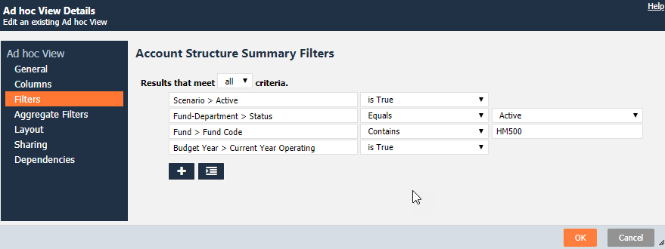
If Aggregation has been enabled in the Columns tab interface, filters can be applied to the aggregated values of the selected Fields. | The interface differs from the standard Advanced Search as the fields available for selection are limited to the Columns that have previously been selected. However associating a field, operator and value works the same way.  If we wanted to Enable Aggregation and select the amount of “Sum of Current Year Budget” as a field, we can exclude results that equal to 0 with the following filter:  - Sum of Current Year Budget> Does Not Equal > 0  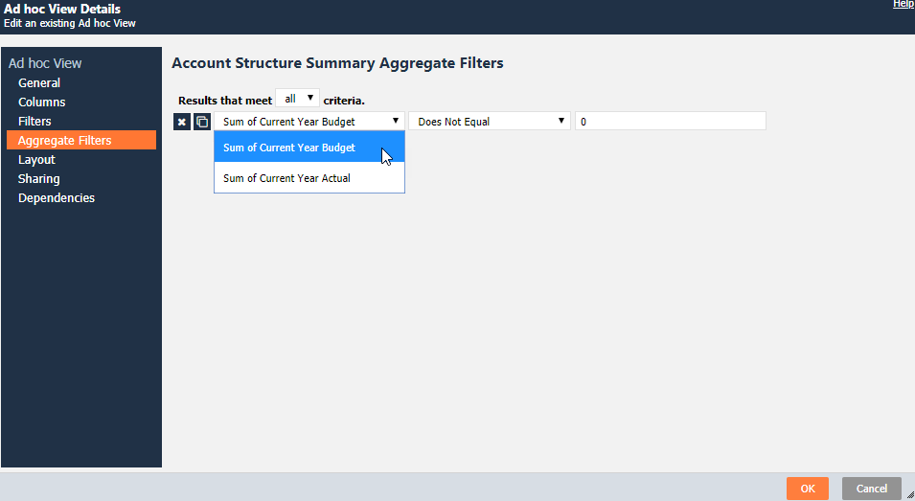
The Layout interface provides you the ability to specify the Sorting and Grouping of the results, set the column widths, show subtotals for grouped data, show columns of grouped data. Click Preview to return the first 100 records. | 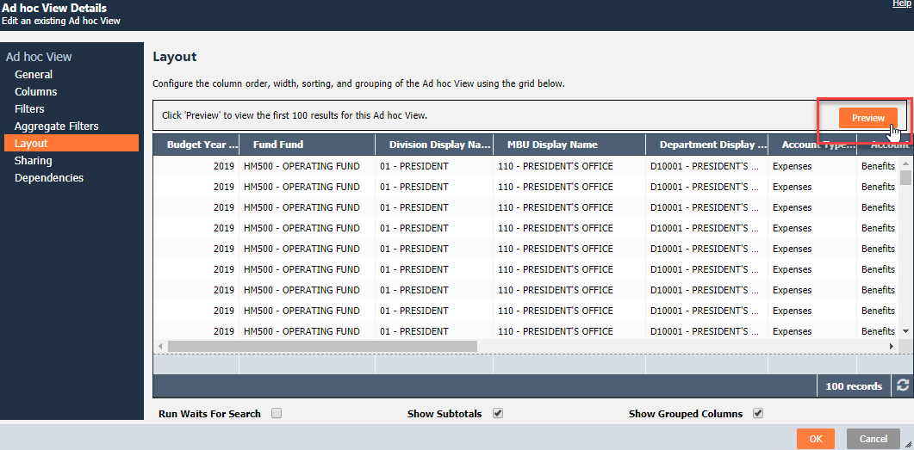
Sharing provides the ability to share and the View with other users.  You can add users to share the View by clicking on the Add Users.  A pop up will appear allowing you to select a user(s). | 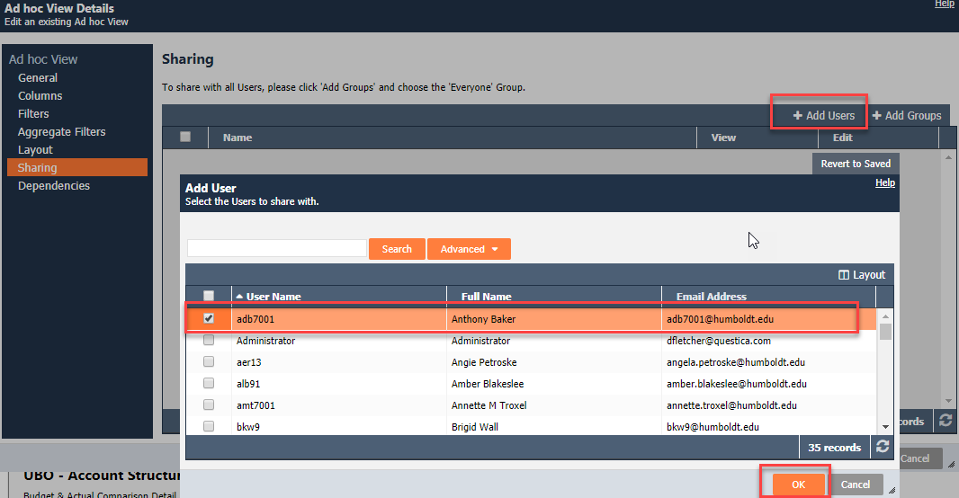
Users then have two permission options: View and Edit | 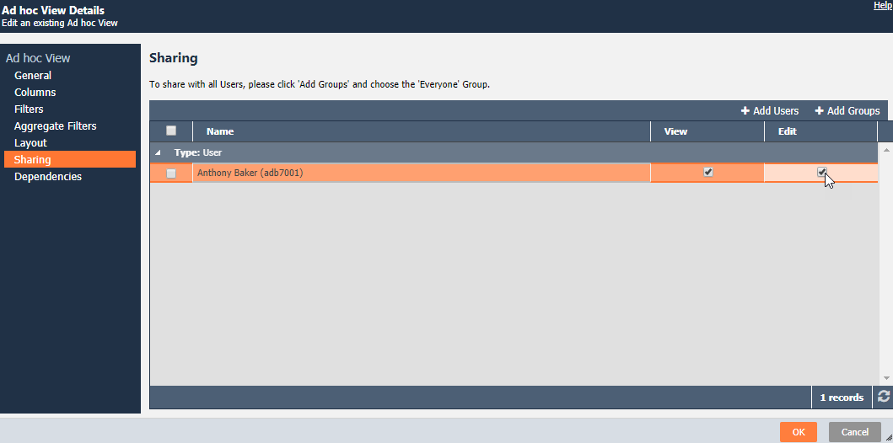
One reason to create Views is to allow users to write reports and create dashboards against the data they need.  To identify which reports are dependent on any given ad hoc the Dependencies tab would list them here. | 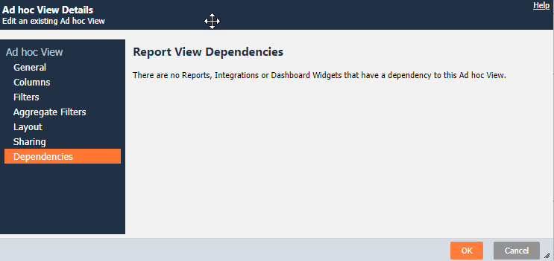

CHANGE HISTORY
Section | DESCRIPTION OF CHANGE IMPLEMENTED | Date | COMPLETED BY
Report Schedules | Select Publish to have reports emailed to you based on the schedule set. | 9/30/19 | Patrick Orona

