QUESTICA BUSINESS PROCESS GUIDE

DATE CREATED | PROCESS NAME
September 27, 2019 | Budget Transfers
PROCEDURE NO. | PROCESS OWNER
005 | Questica Campus Users
DATE OF LAST UPDATE | LAST UPDATED BY
September 27, 2019 | Patrick Orona

Table of Contents
QUESTICA BUSINESS PROCESS GUIDE 1
I. INTRODUCTION 2
II. PROCESS 2
Create a Budget Transfer 2
III. PUBLISHING A BUDGET TRANSFER 7
IV. CREATING AN ALERT 8
V. BUDGET TRANSFER LINES 9
VI. CHANGE HISTORY 9

INTRODUCTION
PURPOSE | The Budget Transfers Module main function is to apply budget revisions to budgets after they have been approved in the year in progress.
SCOPE | Scope of this document pertains to Humboldt State University’s version of Questica Budgeting software. Topics include creating, entering and publishing budget transfers and creating alerts.
DOCUMENT MANAGEMENT | University Budget Office (UBO) retains all copies of Business Process Guides (BPG) and handles distribution.

Note: This BPG assumes that the user will be familiar with browsing web-based, data interfaces (i.e. PeopleSoft, OBI, etc.). There are numerous cascading menus and drop downs available in the interface. Many of these are visible throughout Questica and accessed via entering text and right clicking in grids, cells and headers. Learning to use these will greatly improve your experience.

PROCESS

Create a Budget Transfer
- Follow these steps to enter a Budget Transfer. Make sure to allow pop-ups from hsu.questica.com. To start click Operating in the left panel followed by Budget Transfers in the Operating menu.

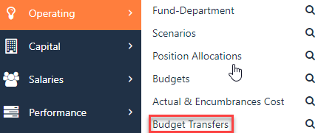

- Check the Budget Year and make sure you are in the correct year (top left of the screen). Budget Transfers are ONLY entered into the current fiscal year.

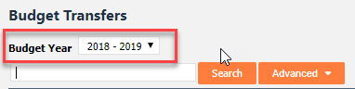

- Click + Add Budget Transfer (top right of the screen).
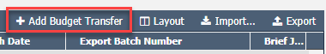

- A window opens. Enter information in the following fields and click OK.

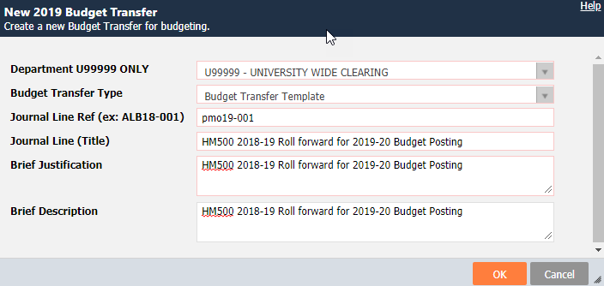

Note: Fields outlined in red are Required to be filled in.

New Budget Transfer
Field | Description
Department U99999 Only | Select U99999 – University Wide Clearing for ALL Budget Transfers. This will enable users to view ALL Budget Transfers entered across campus.
Budget Transfer Type | Budget Transfer Template – most common. Replaces the current Budget Transfer Template form.  The following templates exist but may not be available to all users.  Base Augment – Used by UBO when posting original in the future planning year, reflecting URPC funding decisions, such as additional base allocations for tenure track hires.  Base Budget Adjustment – Used to move operating expenses (OE) and to clear position variances in the future planning year.  Budget Request for Funding (Including New Position) – Not in use  Position Change Form – Not yet in use. Idea is to replace position change form. Cannot enter in the year in progress as it changes original base budget.
Journal Line Ref. | Initials (ALB) current year (19) – user assigned transfer number (001)
Journal Line (Title) | User assigned budget transfer title.  In OBI Journal Line (Title) populates the Journal Line column.  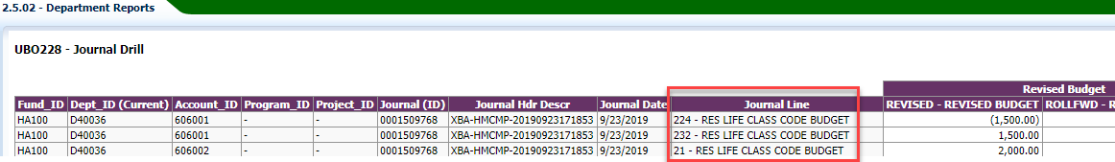
Brief Justification | Justification for this Change Request.
Brief Description | Further details and description of the Change Request.

- A browser tab with the newly created budget transfer will now open. To start, click Budget Transfer in the top left panel. Text entered from the new budget transfer dialogue box above is auto populated.

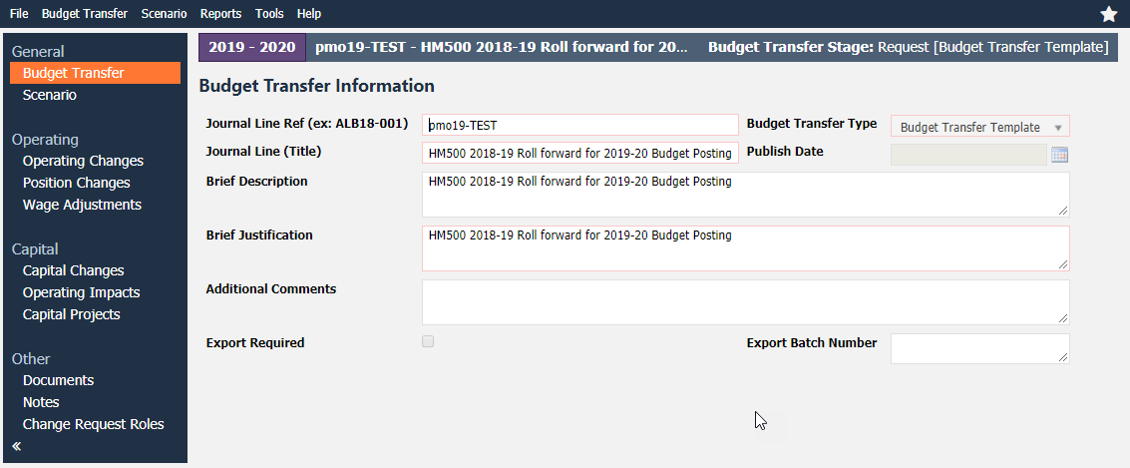

Budget Transfer Information
Field | Description
Additional Comments | If additional comments or more context on the transfer is needed fill out the additional comments box.
Export Required | Do Not Use – For UBO purposes only.
Export Batch Number | Do Not Use – For UBO purposes only.  When Budget Transfer are published and uploaded into PeopleSoft through the overnight integration processes the Questica assigned Export Batch Number is reflected in the Journal column in OBI.  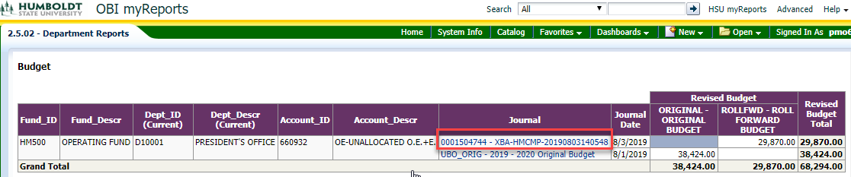

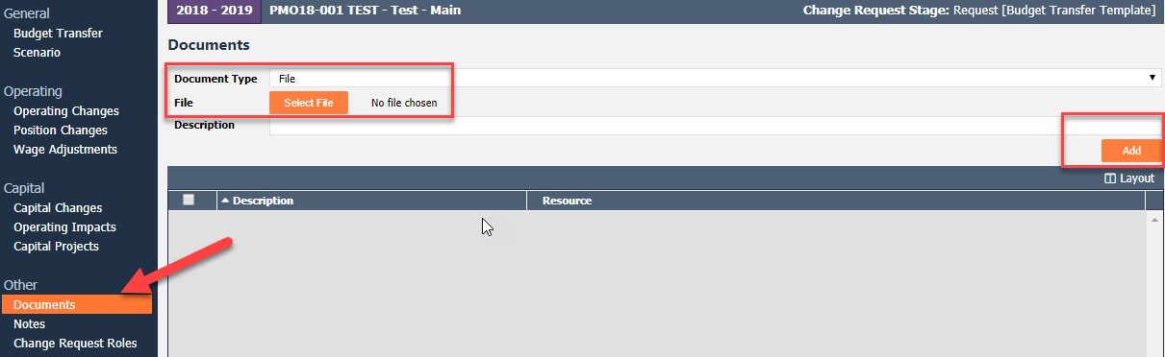
- If there are supporting documents such as VP email approvals, you may add them by selecting Documents on the bottom panel and attaching necessary documents.
- Next click Operating Changes in the left panel. This is where you enter line items for your request. At the top of the grid, in the row just under the column headers, is a place to add a row. Fund-Department, Account, Document Line Description, Budget Scenario and Ledger Group are all required fields. In addition, you can alter the fields (group, sort, filter, etc.) showing by right clicking on the grid header. Please refer to BPG #002 for header bar right click functionality.

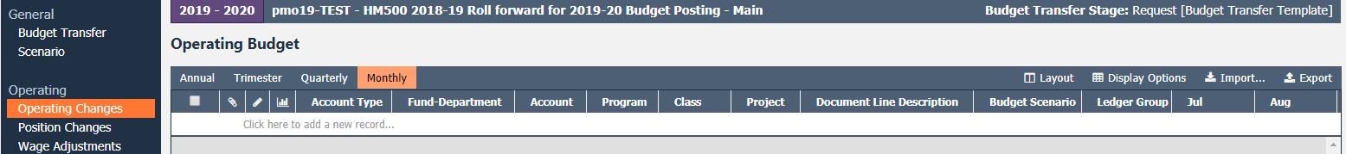

Operating Changes
Field | Description
Account Type | Auto populates field as Revenue or Expenses when account is entered
Fund-Department (Required Field) | Start typing the fund and / or department. As you type, options will appear in the menu based on the criteria entered. Click on desired Fund-Dept. Note: this field includes business unit as a prefix (i.e. HMCMP).  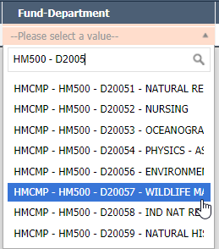
Account (Required Field) | Start typing an accounts code or description. Follow the same procedure as above.
Program / Class / Project | Start typing the code or description. Follow the same procedure as above.
Document Line Description (Required Field) | Enter a description for the line items. DO NOT USE COMMAS. This will cause integration errors when uploading transfers into PeopleSoft
Budget Scenario  (Required Field) | Enter the correct budget transfer category.  REVISED – MOST COMMON SCENARIO - EXPENDITURE BUDGET ONLY ‐ Used by departments to allocate expenditure budgets – should always net to zero and does not increase revenue budget  Additional scenarios below are currently used by the Budget Office and can be seen within the Budget Transfer Lines grid.  ALLOCATION – Budget allocations from the CO, excluding any allocations that are part of the Original Budget  BASE_CHG – Not applicable. Do Not Use  BDCAMPUS – Campus budget conversion  COMP – Used when funding mandatory compensation increases from the centrally held compensation pool  ENCUMB – Used to allocate budget to cover the cost of existing encumbrances at year‐end.  ONETIME – Used to allocate funding for one‐time allocations approved with the annual budget  ORIG_PROJ – Original project budget  ORIGINAL – Ongoing base budget, should only be used to load initial budget each year  OTH_SPEC – Used to reflect revenue budget changes other than ALLOCATION  PTD – Project to date  ROLLFWD – Used to allocate roll forward (carry forward), which reflects unspent budget from the prior year
Ledger Group (Required Field) | Select STANBUD. The only option.
Dollar Entry in Month (Required Field) | Ensure the Monthly display option is selected and enter the dollar amount for the line item under the applicable month, this would be the current open accounting period or later. Then press Enter or click elsewhere on the grid to save the line item.

- Enter as many line items as are necessary. The net total must be zero. The request will not be allowed to be promoted if this is not met.
Invalid Entry
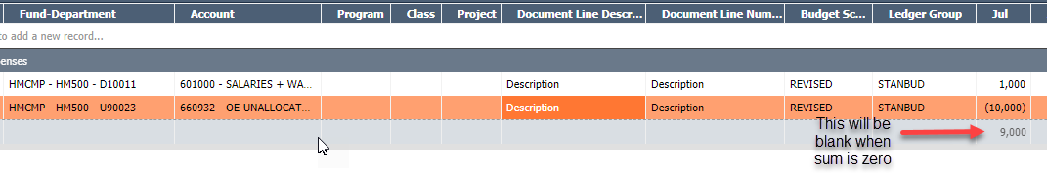
Valid entry
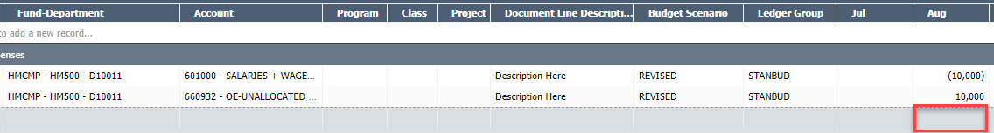

- If a grid row does not have all of the required information an error message will be generated and appear at the bottom of the screen.
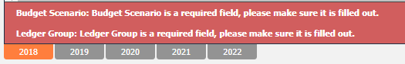

- Exporting & Importing Budget Transfers - Users have the option to enter directly into the Budget Transfers grid or export an excel spreadsheet, complete it, and import back in. Refer to Questica Import Export Excel Spreadsheet Tips for instruction.
- To save and close a Budget Transfer click File and Save at the top right of the screen. The Budget Transfer can be returned to at a later time to be completed.
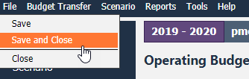

Budget Transfer is created as seen below
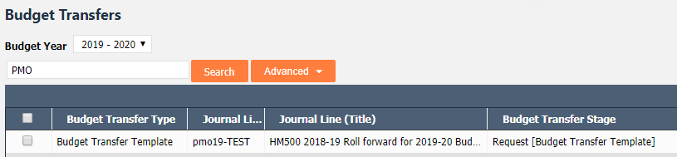

- When complete, you will need to promote it to the next stage for review. Click the Budget Transfer menu and select Promote.

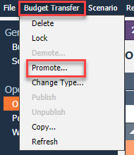

- Next, select UBO (University Budget Office) from the drop-down in the Promote to field. Once promoted, all fields will grey out and further changes are not allowed. If modifications are required after promotion, contact UBO to demote the budget transfer.

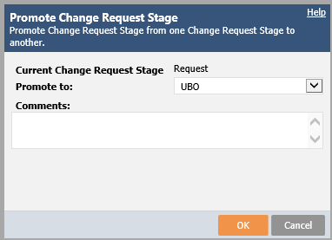

Open promoted Budget Transfer to view stage at the top right hand side as seen below.

PUBLISHING A BUDGET TRANSFER
University Budget Office next steps:

- Review: UBO will review to ensure transfer is in accordance with HSU policy and promote or demote, if necessary, to user for adjustments. If transfer is demoted, UBO will contact the user for further instruction or clarification.
- Processed: After the UBO reviews and publishes the budget transfer, the stage will change to Processed similar to above.
- Posted: You will now be able to see the Budget Transfer within the applicable Fund-Department and will then be loaded into PeopleSoft. The transactions will typically show in OBI the day after they are published in Questica.
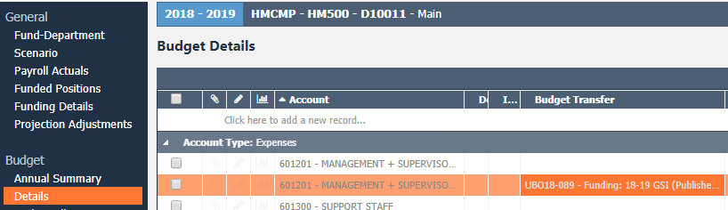
Below shows a Published Budget Transfer within a Fund-Department.

CREATING AN ALERT
- If you select Tools in the top menu bar, you can select Create Subscription which will email an alert if anybody performs a specific action, such as modifies the Budget Transfer in any way or promotes it as seen below.

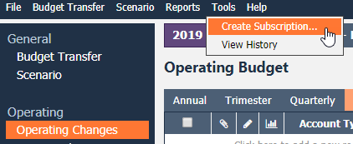

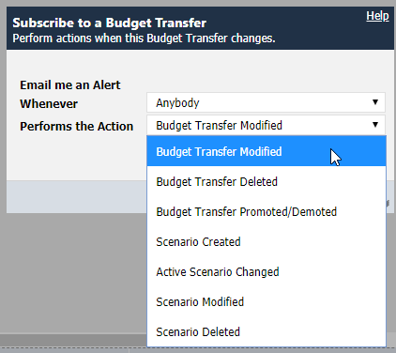

- To edit or delete the alert click Alerts in the Welcome back menu
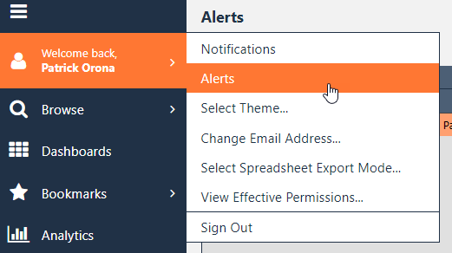

- Right click on the record and perform desired action.
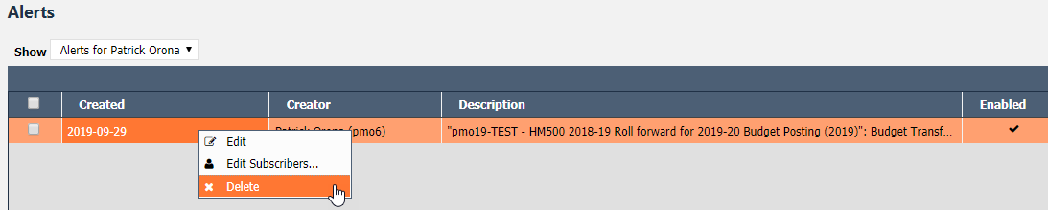

BUDGET TRANSFER LINES
The Budget Transfer Lines view shows budget transfer line item detail for ALL budget transferred entered in one grid and has the same functionality as the Budgets grid. Refer to BPG #002 & 003 for advanced search and right click header bar functionality.

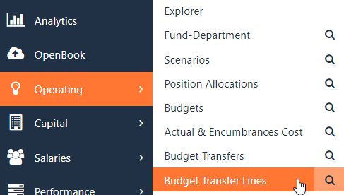

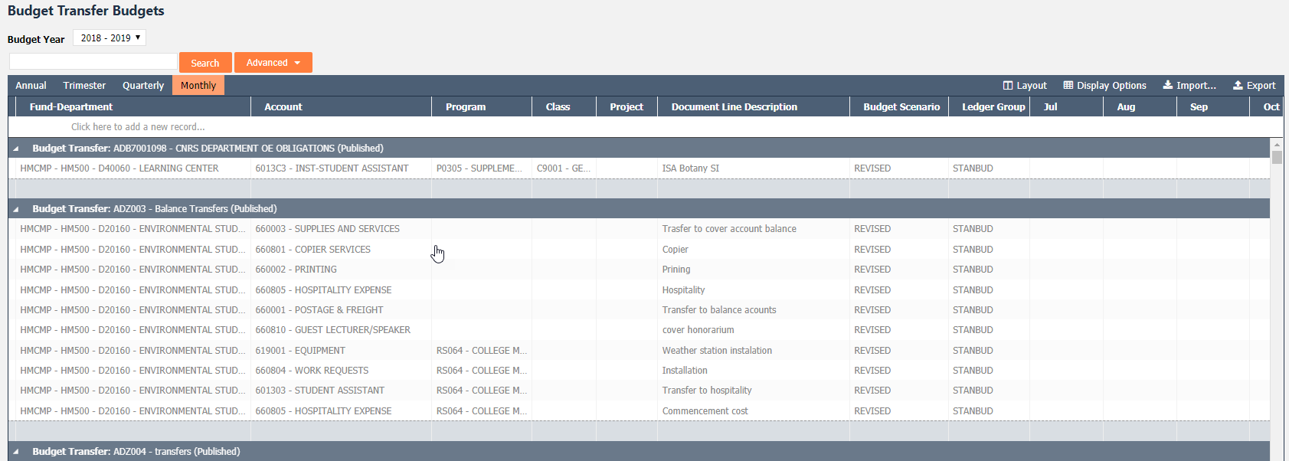

CHANGE HISTORY
Section | DESCRIPTION OF CHANGE IMPLEMENTED | Date | COMPLETED BY
N/A | N/A | N/A | N/A

